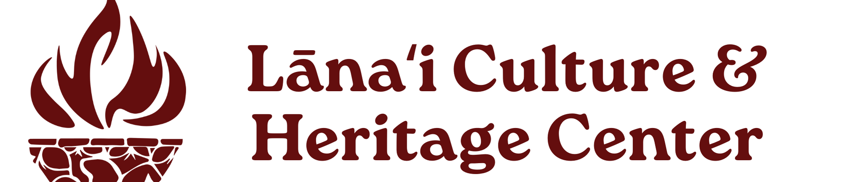
Auction Donation Form
Mahalo for your support of Lānaʻi Culture & Heritage Center. Send the completed form to Lānaʻi CHC Administrative Assistant and Outreach Coordinator Crystal Bolo at Crystal@lanaichc.org or Jacque@TranscendencePacific.com
or call 808.565.7177.

contact information

Donor Name & Title: ___________________________________________________________
Organization Name: ___________________________________________________________
Address: ____________________________________________________________________
City: State: ZIP Code: _________________________________________________________
Phone: ______________________________________________
Email: _______________________________________________
donation information
Name of Item(s): __________________________________________________________________
________________________________________________________________________________Estimated Dollar Value(s): ___________________________________________________________
Expiration Date: ___________________________ (Date of issuance should be March 7)
Brief Description of Donation(s): ______________________________________________________ ________________________________________________________________________________
________________________________________________________________________________

Monetary Donation. If your company prefers to make a monetary donation, complete this section of the form. Sponsorship opportunities and tournament tickets are also available.

□ Check Enclosed
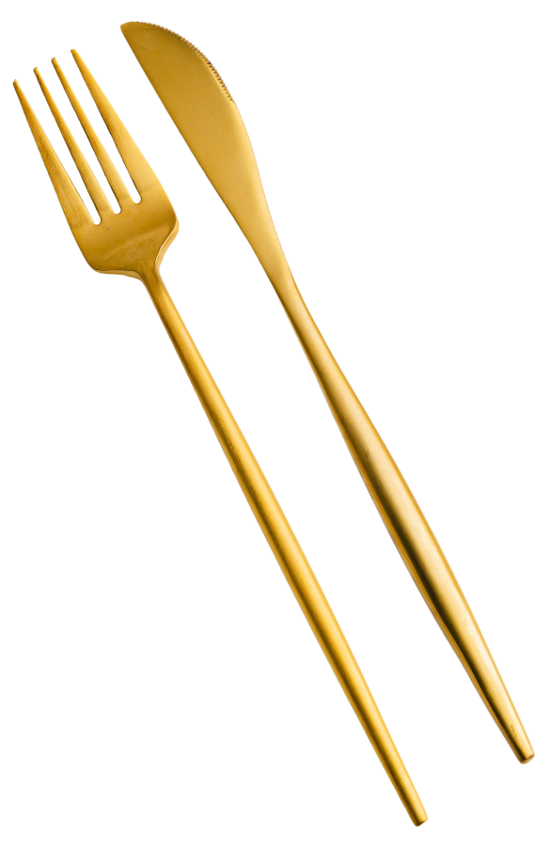
□ Contact Crystal@lanaichc.org if an invoice/purchase order is required or to pay by credit card

