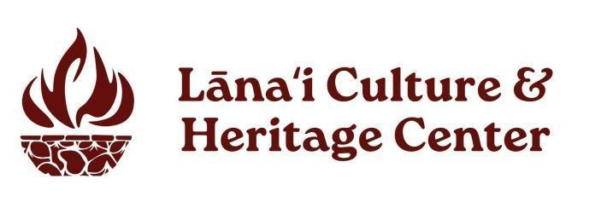

2026 golf tournament Sponsorship Benefits & Commitment Form
Mahalo for your support of Lānaʻi Culture & Heritage Center. Send the completed form to Lānaʻi CHC Administrative Assistant and Outreach Coordinator Crystal Bolo or at Crystal@lanaichc.org or call 808.565.7177.

Company Information (“Sponsor”) – Company name as it wishes to be acknowledged
Company Name: ___________________________________________________________
Address: _________________________________________________________________
City: State: ZIP Code: ________________________________________________________
Primary Contact: for Player List, Marketing & Event Logistics
Contact Name: ________________________________________
Phone: _______________________________________ Email: _____________________________________________
Participant Info
Total Number of Players __________________________
First & Last Name of Players _____________________________________ ____________________________________
_____________________________________ _____________________________________
_____________________________________ _____________________________________
_____________________________________ _____________________________________
Golf Packages (each sponsorship accommodates 4 players) □ $8,500 Presenting Sponsor □ $3,250 Nāʻū Sponsor □ $2,500 Kaunaʻoa Sponsor
Payment Method: Payment is due prior to the event
Billing Name (if different from above): _________________________________________________________________
Billing Contact Name: ________________________ Billing Contact Email: ___________________________________
Billing Address (if different from above): _____________________________City: State: ZIP Code: _________________
□ Check Enclosed

□ Contact us at Crystal@lanaichc.org if an invoice/purchase order is required or to pay by credit card.

